**Continuous Integration and Continuous Delivery/Deployment**

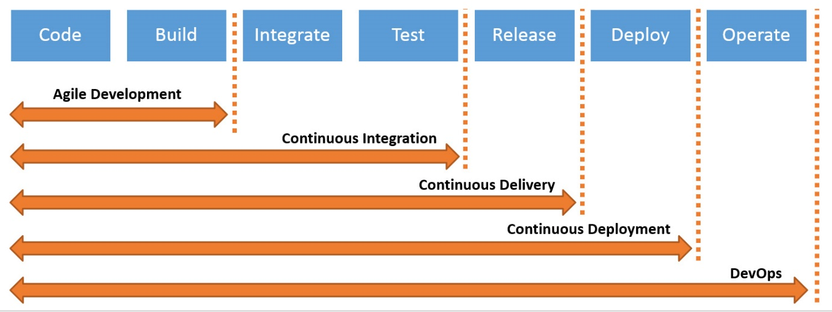

**Build vs Release pipeline** In Build pipeline we are generating artifact, but in release pipeline we are using artifact.

**Jenkins Plugin** Plugins are the primary means of enhancing the functionality of a Jenkins environment to suit organization- or user-specific needs. There are over a thousand different plugins which can be installed on a Jenkins controller and to integrate various build tools, cloud providers, analysis tools, and much more. **Note: Plugin will not add functionality to your system it will add functionality in jenkins**

**What is Jenkins? Jenkins is a schedular.**

Jenkins is an open-source automation server. It helps automate the parts of software development related to building, testing, and deploying, facilitating continuous integration and continuous delivery. It is a server-based system that runs in servlet containers such as Apache Tomcat.

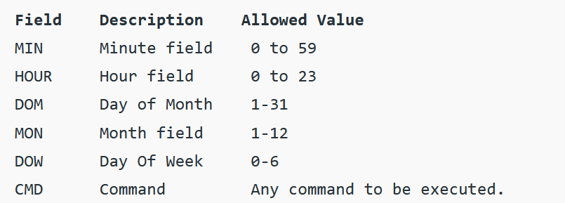

**How CICD setup in your environment?** Answer: By Uplift jobs

**WOW in Jenkins**

* To perform frequent integrations and deployments we need a tool which can help us doing the same stuff and integrate with multiple tools. These tools are generallyt called as CI/CD Engines
* Jenkins is popular Opensource CI/CD Engine
* When we install jenkins we will have a user created called as jenkins.
  + From jenkins we can perform anything which jenkins user can perform
* What happens when we install jenkins  
  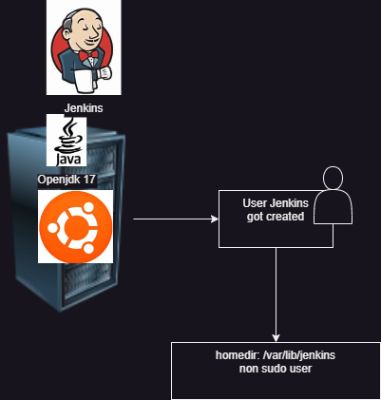
* How can we integrte jenkins with any other tools:
  + Command line: call the command line
  + Plugin + installation/configuration:
    - UI or Pipeline step
* Refer in the classroom video for
  + Compiler vs interpreter vs hybrid
  + PATH variable
  + Environment variable

**Adding sudo permission to Linux user**

sudo visudo

jenkins (ALL:ALL) NOPASSWD:ALL